OXYMORONS
NAME:

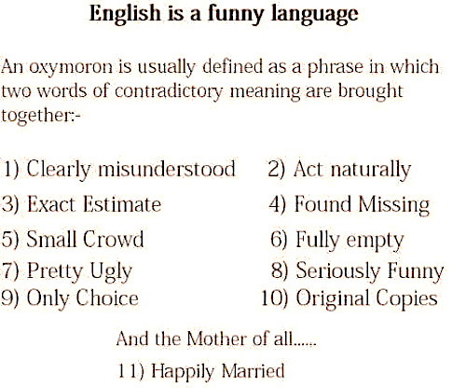

While the last one is clearly a joke, the others are actually oxymorons commonly used today. Thinking about it, how many of them have you read in a book or heard in normal conversation?
Now, I want you to try to make your own list of oxymorons (maybe you could use them in a story some day!).

1. What is an oxymoron (in your own words tell us what it means):

2. Come up with at least 5 oxymorons of your own (you can always do more!):

