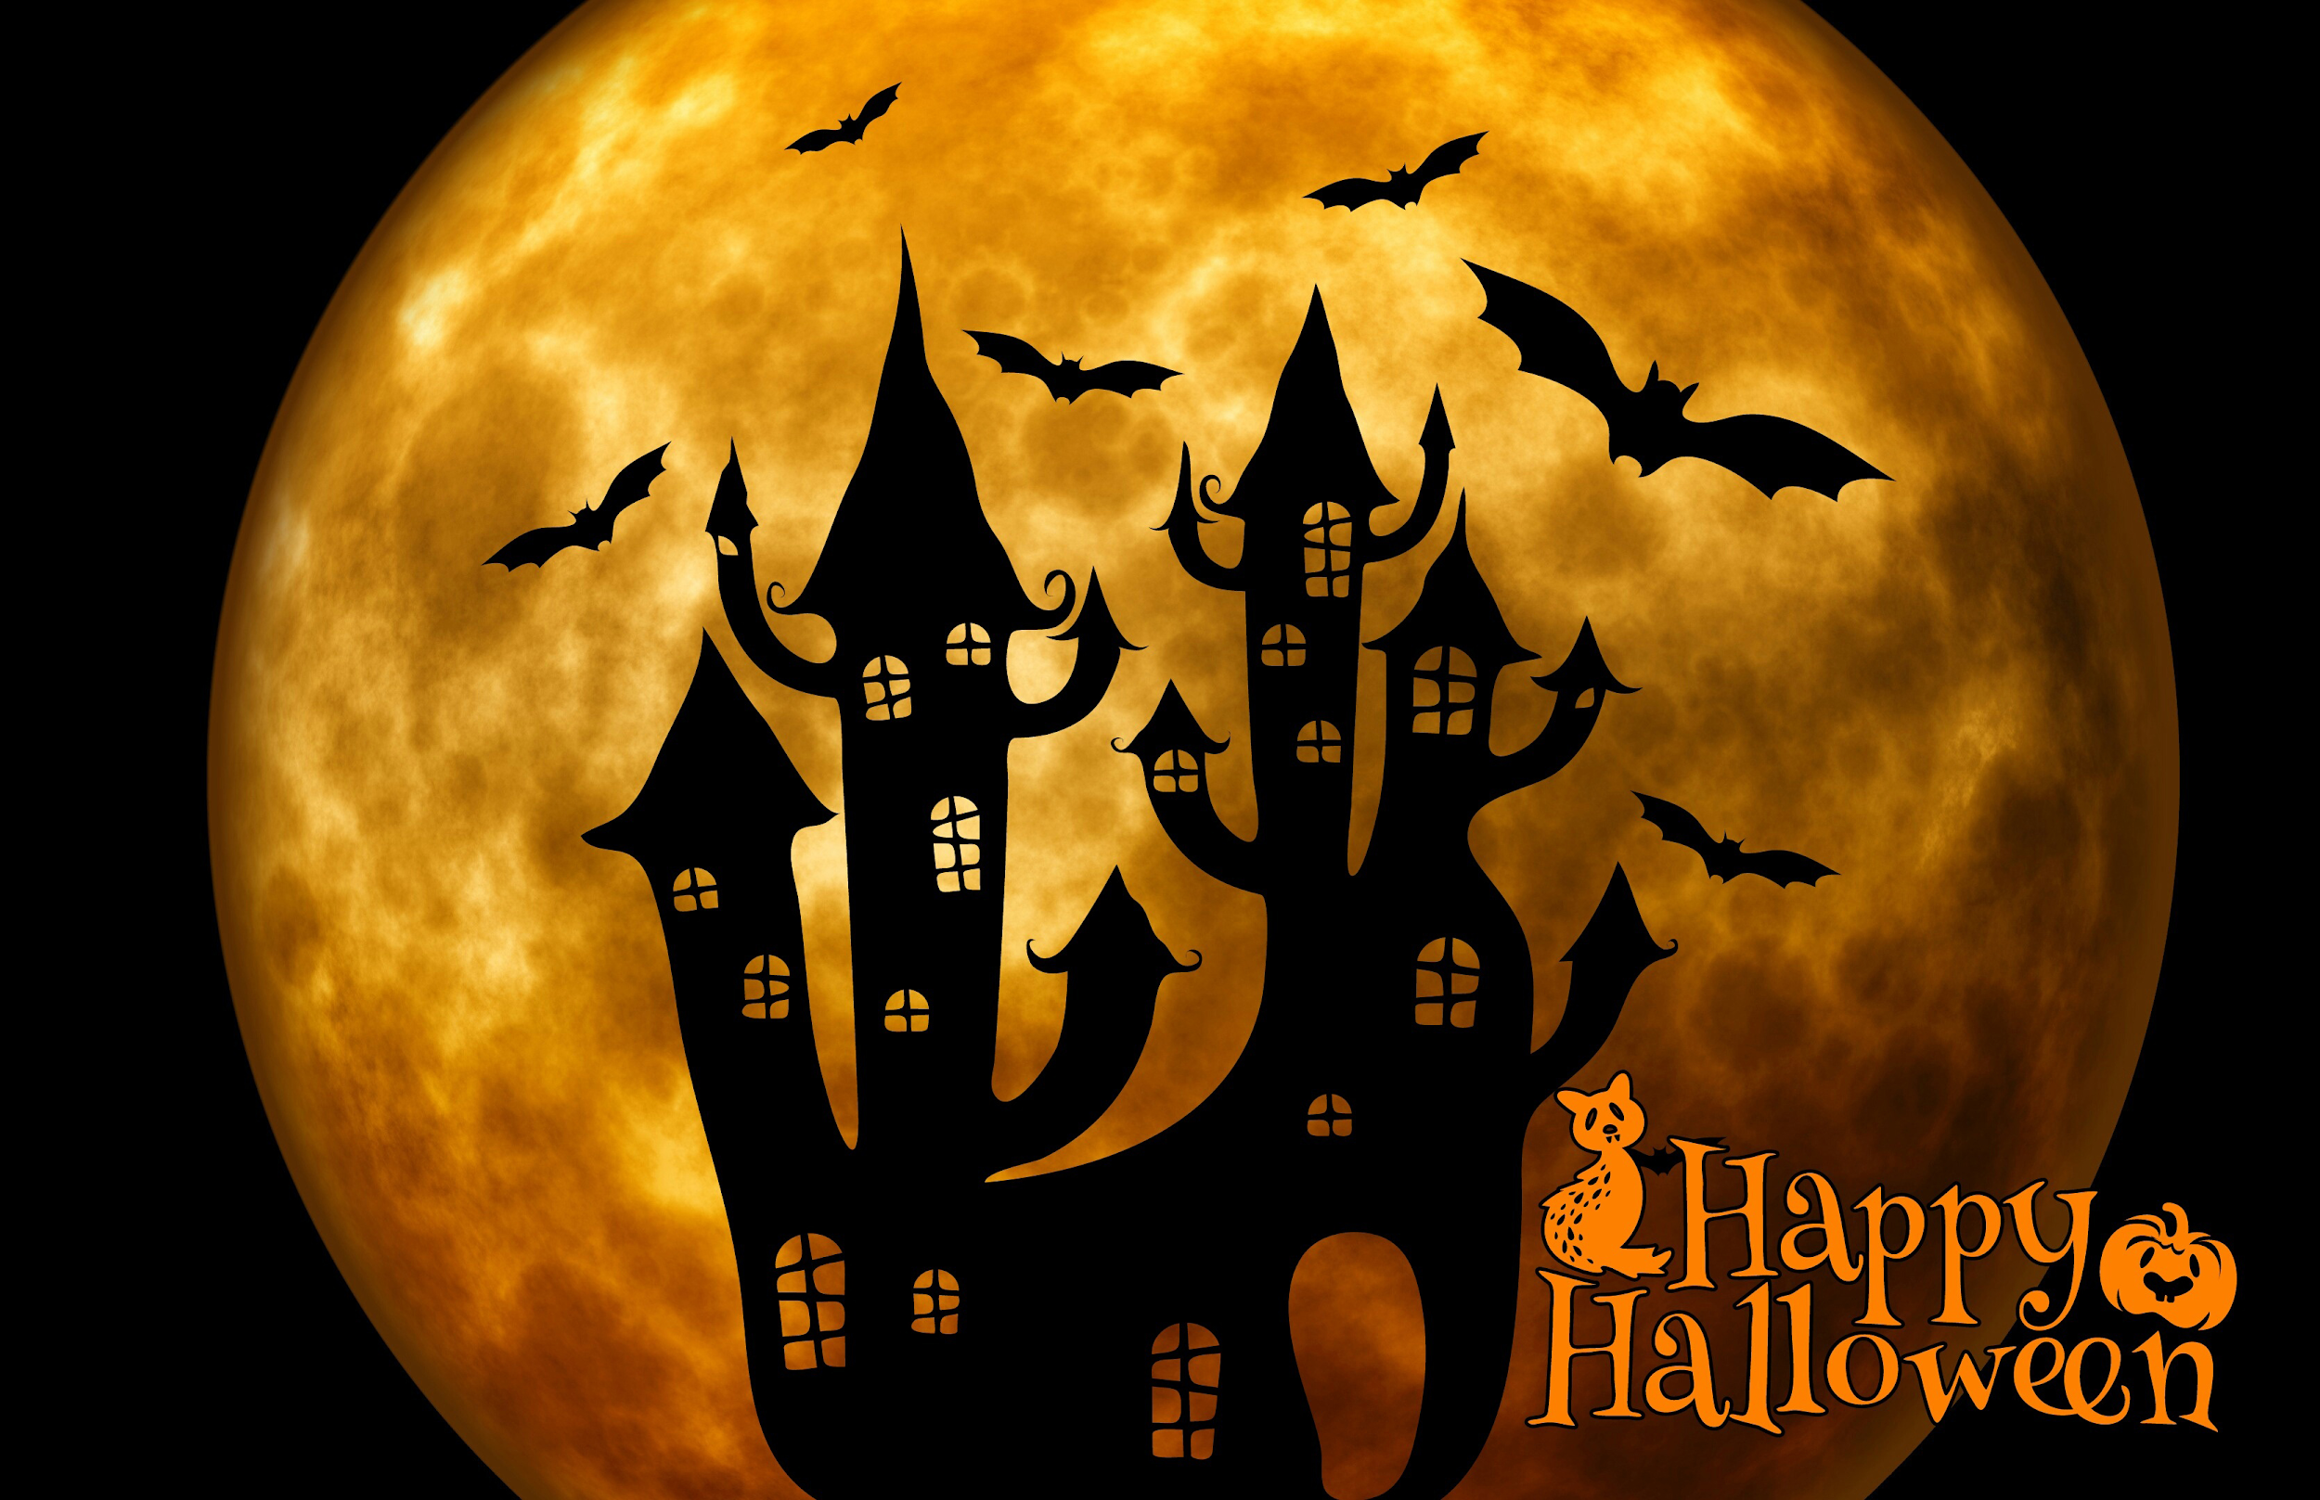
DIRECTIONS:

Choose one of the writing prompts below and complete it on the back of this paper.

Keep it school appropriate!

You must have a minimum of 150 words to get full credit.

You may attach additional pages as needed to the back of this paper.

WANT SOME EXTRA CREDIT?
You may do an additional one for extra credit. Write it on a separate piece of paper and label it extra credit. Staple it to this sheet. Worth 10 points in homework.

- Finish the story: While trick or treating, my friends and I decided to explore Hidden Avenue, a dark street we’d never noticed before.
- Finish the story: While trick-or-treating we passed a cemetery. Suddenly we all felt cold.
- Finish the story: It was a regular Halloween, until the monsters declared to the world they were real, and they were taking Halloween for themselves.
- Finish the story: Everyone in the town got the same text message on Halloween at 5pm.
- Write about a town that has banned Halloween.
- Write about a foreign exchange student experiencing Halloween for the first time.
- Write a story about the best Halloween ever.
- Write a story about a ghost wanting to go trick-or-treating.
- Write a story about a Jack-o-Lantern that starts to speak to trick-or-treaters.
- Write a Halloween poem about trick-or-treating, ghosts, monsters, magic, etc.
- Write a recipe for a magic potion or spell, and explain what happens in a story format.
- Write out the “rules” for Halloween in a town full of monsters.
- Write about a Halloween from the monster’s perspective.
- Create a new Halloween monster and myth.
- Or suggest your own…
Name: ___________________________________________ Title: _____________________________________________________________
________________________________________________________________________________________________________________________
________________________________________________________________________________________________________________________
________________________________________________________________________________________________________________________
________________________________________________________________________________________________________________________
________________________________________________________________________________________________________________________
________________________________________________________________________________________________________________________
________________________________________________________________________________________________________________________
________________________________________________________________________________________________________________________
________________________________________________________________________________________________________________________
________________________________________________________________________________________________________________________
________________________________________________________________________________________________________________________
________________________________________________________________________________________________________________________
________________________________________________________________________________________________________________________
________________________________________________________________________________________________________________________
________________________________________________________________________________________________________________________
________________________________________________________________________________________________________________________
________________________________________________________________________________________________________________________
________________________________________________________________________________________________________________________
________________________________________________________________________________________________________________________
________________________________________________________________________________________________________________________
________________________________________________________________________________________________________________________
________________________________________________________________________________________________________________________
________________________________________________________________________________________________________________________
________________________________________________________________________________________________________________________
________________________________________________________________________________________________________________________

