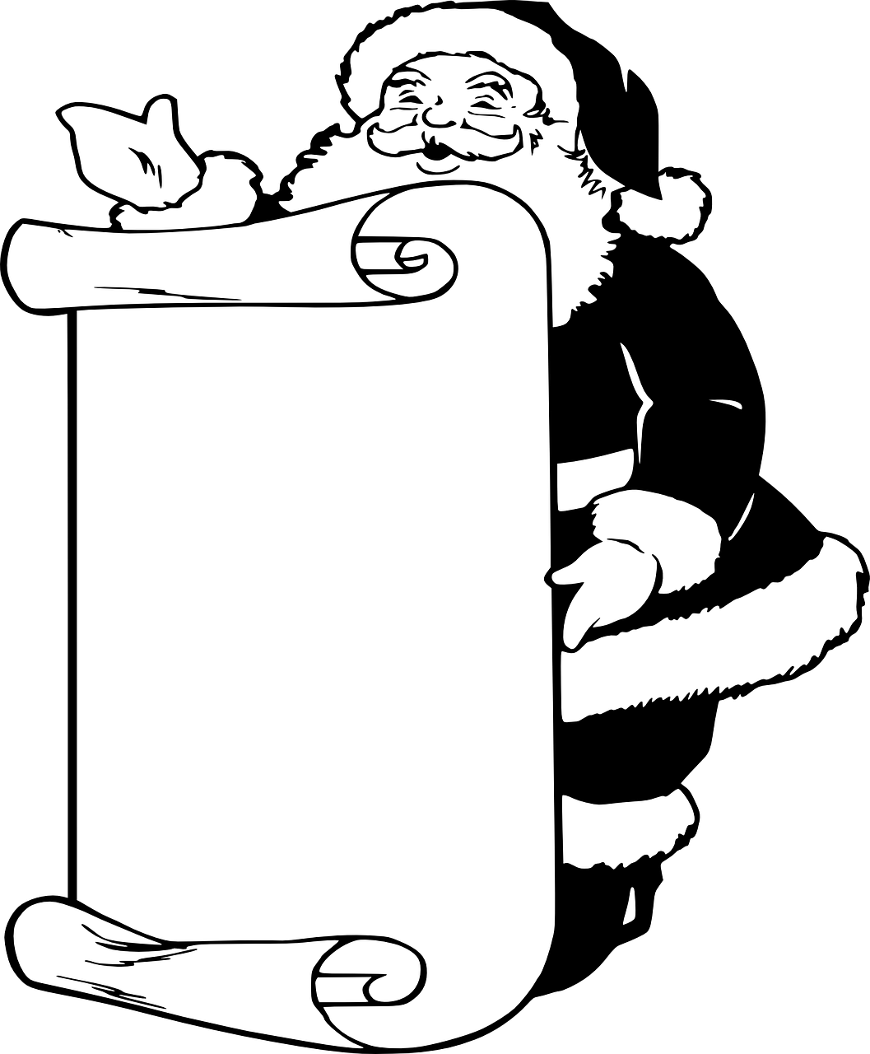
Happy holidays and a
welcome long break

Choose one of the writing prompts below and complete it on the back of this paper. Keep it school appropriate! You must have a minimum of 150 words to get full credit. You may staple additional pages to the back as needed.
You may do an additional one for extra credit. Write it on a separate piece of paper and label it as extra credit. Worth 10 points in homework.

1. Write a story about a holiday tradition in a genre (historical, sci-fi, fantasy, western, etc.).
2. Write a story focusing on a holiday other than Christmas. Explain the customs and traditions. Have a character explore it.
3. Joey just found out he’s on Santa’s naughty list. Write him trying to work his way onto the nice list in time for Christmas.
4. Write a story about the biggest winter storm ever, and it’s going to hit this weekend.
5. Santa’s out sick. Write a story where someone else must deliver the presents (Mrs. Clause, the elves, etc.).
6. Write a story from the perspective of one of Santa’s reindeer, and the reindeer isn’t happy…
7. Write a story or poem featuring the meaning of a holiday.
8. Rewrite one of the classic holiday stories in a unique and new way.
9. Write about a family obsessed with the holiday, to the point of extremism.
10.. or suggest your own…
Name: ___________________________________________ Title: _____________________________________________________________
________________________________________________________________________________________________________________________
________________________________________________________________________________________________________________________
________________________________________________________________________________________________________________________
________________________________________________________________________________________________________________________
________________________________________________________________________________________________________________________
________________________________________________________________________________________________________________________
________________________________________________________________________________________________________________________
________________________________________________________________________________________________________________________
________________________________________________________________________________________________________________________
________________________________________________________________________________________________________________________
________________________________________________________________________________________________________________________
________________________________________________________________________________________________________________________
________________________________________________________________________________________________________________________
________________________________________________________________________________________________________________________
________________________________________________________________________________________________________________________
________________________________________________________________________________________________________________________
________________________________________________________________________________________________________________________
________________________________________________________________________________________________________________________
________________________________________________________________________________________________________________________
________________________________________________________________________________________________________________________
________________________________________________________________________________________________________________________
________________________________________________________________________________________________________________________
________________________________________________________________________________________________________________________
________________________________________________________________________________________________________________________
________________________________________________________________________________________________________________________

